ADDENDUM NO. 1

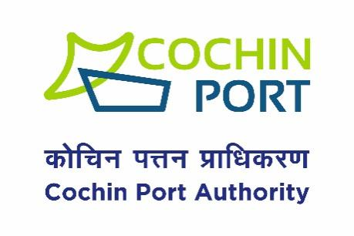

CHIEF ENGINEER’S OFFICE,

WILLINGDON ISLAND, COCHIN-682 009,

Phone: 0484-2666414, 2582400/ 2582406

Email:[ce@cochinport.gov.in](mailto:ce@cochinport.gov.in)/coptce@gmail.com

Website:[www.cochinport.gov.in](http://www.cochinport.gov.in)

Tender No. T15/T-2027/2024-C

Name of the work: **DE-SILTATION OF THE AREA UNDER FIRE PUMP HOUSE AT MULT JETTY USING CUTTER SUCTION DREDGER**

**Sub:- Pre-bid meeting of Tender No: T15/T-2027/2024-C**

**Date & Time:-Tuesday, November 05, 2024 at 14:30 Hours IST**

**Meeting link:**

<https://teams.microsoft.com/l/meetup-join/19%3ameeting_Yjk0MjdhOTUtYjVmYi00ZDMwLWJlY2UtYjg3NzQwZGE3ODAw%40thread.v2/0?context=%7b%22Tid%22%3a%22ab451355-f9bf-410e-8b55-82da9e38dc90%22%2c%22Oid%22%3a%22f5eba0f6-0698-4e31-bd0a-04acc3e22f9b%22%7d>

**Sd/-**

**CHIEF ENGINEER**

**COCHIN PORT AUTHORITY**