ADDENDUM / CORRIGENDUM NO. 1

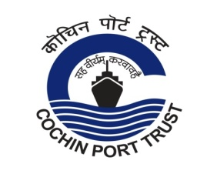 | COCHIN PORT TRUST  An ISO-9001:2015 & ISPS Compliant Port

Phone : 2666414, 2582400 CHIEF ENGINEER’S OFFICE,
Telefax : 91 0484 2666414 COCHIN – 682 009.
Email :ce@cochinport.gov.in, coptce@gmail.com
Website: www.cochinport.gov.in

No.T15/T-1946/ 2021-C Dated: 02-07-2021

Tender for Construction of International and Domestic Cruise Terminal and Other Allied Facilities at Mormugao Port Trust, Goa, through Engineering, Procurement and Construction (EPC) Contract
(Tender No. No.T15/T-1946/ 2021-C)

Please note the following:

Sl. No | Item details | Existing | To be read as
1 | Pre-Bid Meeting | 15.00 hours on 02-07-2021 through Video Conferencing | 15.00 hours on 09-07-2021  through Video Conferencing

All other terms & conditions of tender remain unchanged

Sd/- CHIEF ENGINEER

