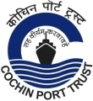
COCHIN PORT TRUST
Civil Engineering Department
E-Tender No. T15/T-1946/2021-C

NOTICE INVITING REQUEST FOR PROPOSAL
FOR
Construction of International and Domestic Cruise Terminal and Other Allied Facilities at Mormugao Port Trust
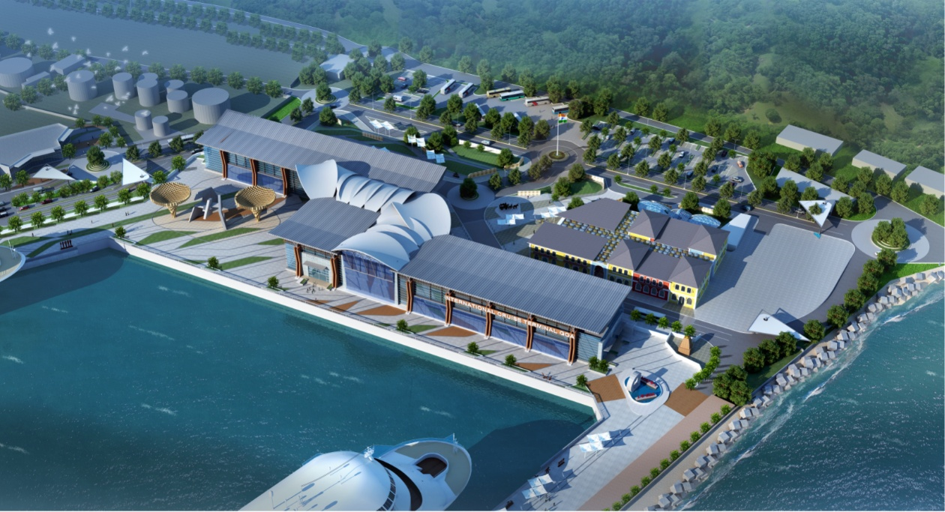
VOLUME-VII
FINANCIAL PROPOSAL
JUNE 2021
Chief Engineer, Cochin Port Trust
Willingdon Island, Cochin-682009, Kerala
www.cochinport.gov.in
COCHIN PORT TRUST

VOLUME VII: FINANCIAL PROPOSAL

Name of Work: CONSTRUCTION OF INTERNATIONAL AND DOMESTIC CRUISE TERMINAL AND OTHER ALLIED FACILIITIES AT MORMUGAO PORT TRUST, GOA, THROUGH EPC CONTRACT
(Bid No.T15/T-1946/2021-C)
Item  No. | Description of Work | Unit | Bidder Quoted Amount in figures  (in Rupees) | Bidder Quoted Amount in words  (in Rupees)
(1) | (2) | (3) | (4) | (5)
1 | Engineering, Procurement, Construction, Delivery, Installation, Testing and Commissioning of the facilities envisaged under "Construction of International and Domestic Cruise Terminal and other allied facilities at Mormugao Port Trust, Goa through EPC Contract" in conformity with the Bid Documents comprising Invitation of Bid, Instructions to Bidders, General Conditions of Contract, Special Conditions, Employer’s Requirements including Scope of Work, Technical Specifications, Design Criteria and Drawings etc., including remedying any Defects in the Works as specified therein. | Lumpsum
GRAND TOTAL (excluding GST)
[Rupees in figures and in words]

SIGNATURE OF BIDDER

