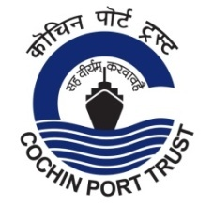
Press Release

The third group of Indian expatriates evacuated from Maldives
arrived at Cochin Port

The third group of Indian expatriates evacuated from Maldives arrived at Cochin Port by INS Jalashwa today (17/05/2020) at 11 30 AM.
The resources available at Samudrika Cruise Terminal of Cochin Port Trust have been made available for handling these expatriates arriving as part of 'Operation Samudra Setu' launched by Indian Navy.
The first group of 698 persons evacuated from Maldives was brought to Cochin Port on 10.05.2020 in the first trip of 'INS Jalashwa'. The second group having 202 persons arrived at Cochin by India Navy ship 'INS Magar' on 12.05.2020. The third group arriving today in the second trip of INS Jalashwa has 588 expatriates. In all, the Port has facilitated safe transit of 1488 Indian expatriates.
The vessel is berthed at BTP Jetty and the disembarkation procedures, including examination & clearance by PHO, Customs and Immigration, are being carried out inside Samudrika Terminal.
The District Administration, Police Dept and other Government agencies are coordinating transportation, quarantine facilities, ambulances etc. (17/05/2020)

Follow us on Twitter @cochin_port
www.cochinport.gov.in

